**Introduction:**

A function is a block of code that performs a specific task.

Suppose, you need to create a program to create a circle and color it. You can create two functions to solve this problem:

* create a circle function
* create a color function

Dividing a complex problem into smaller chunks makes our program easy to understand and reuse.

## **Types of function**

There are two types of function in C programming:

* [Standard library functions](https://www.programiz.com/c-programming/library-function)
* [User-defined functions](https://www.programiz.com/c-programming/c-user-defined-functions)

### **Standard library functions**

The standard library functions are built-in functions in C programming.

These functions are defined in header files. For example,

* The printf() is a standard library function to send formatted output to the screen (display output on the screen). This function is defined in the stdio.h header file.  
   Hence, to use the printf() function, we need to include the stdio.h header file using #include <stdio.h>.
* The sqrt() function calculates the square root of a number. The function is defined in the math.h header file.

### **User-defined function**

You can also create functions as per your need. Such functions created by the user are known as user-defined functions.

## 

## 

## **How user-defined function works?**

#include <stdio.h>

void functionName()

{

... .. ...

... .. ...

}

int main()

{

... .. ...

... .. ...

functionName();

... .. ...

... .. ...

}

The execution of a C program begins from the main() function.

When the compiler encounters functionName();, control of the program jumps to

void functionName()

And, the compiler starts executing the codes inside functionName(). The control of the program jumps back to the main() function once code inside the function definition is executed.

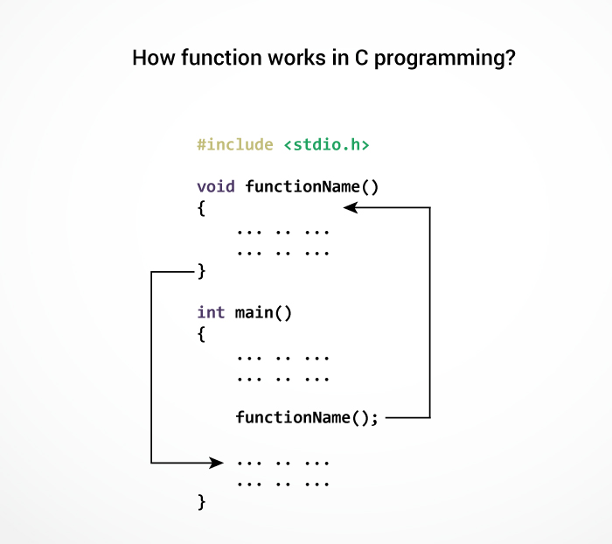

## **Example: User-defined function**

Here is an example to add two integers. To perform this task, we have created an user-defined addNumbers().

#include <stdio.h>

int addNumbers(int a, int b); // function prototype

int main()

{

int n1,n2,sum;

printf("Enters two numbers: ");

scanf("%d %d",&n1,&n2);

sum = addNumbers(n1, n2); // function call

printf("sum = %d",sum);

return 0;

}

int addNumbers(int a, int b) // function definition

{

int result;

result = a+b;

return result; // return statement

}

**Output:**

Write on your own...